A REMARKABLE COLLECTION
ON TOUR !
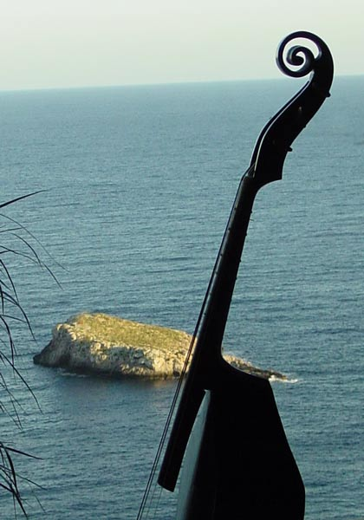

The Orpheon Foundation
Museum of Historical Musical Instruments
In the service of a living tradition...
www.orpheon.org orpheon@gmx.at
Praterstrasse 13/2/11, A-1020 Wien, Austria
Tel: +43-650-4003731
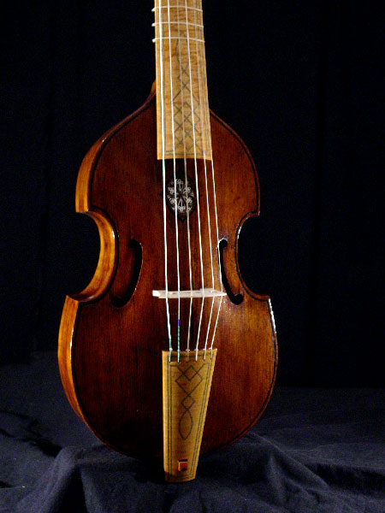
Venerable Ambassadors
From a Distant Past

Orpheon wishes to open your eyes and ears to the marvelous world of string instruments of the Renaissance, the Baroque and the Classical Periods.The collection now contains over 170 violins, violas , violoncellos, violas da gamba, violas d'amore, barytons and historical bows dating mostly from 1560 to 1780, all restored to their original playing conditions and placed at the disposal of members of the Orpheon Consort, professional musicians and outstanding students from all over Europe for competitions, recordings, concerts and long-term study.

Its owner, Prof. José Vázquez of the University for Music and the Performing Arts Vienna holds that it is the living acoustical heritage - the sounds that these instruments produce for those living today - that interests us, and not their mere decorative flair as objets trouvés from aristocratic residences of a distant past. We wish to hear what these instruments have to say and we wish to learn from them about the manner of performance of their musical heritage from the Renaissance, the Baroque and the Classical Periods.
Defining our mission
It is a singularly beautiful and unique - perhaps even miraculous - process, which Orpheon wishes to preserve for mankind, linking our past and our present with our future, a process which began perhaps four hundred years ago on a modest work bench in a modest atelier, with a dedicated man breathing life into a plank of wood…
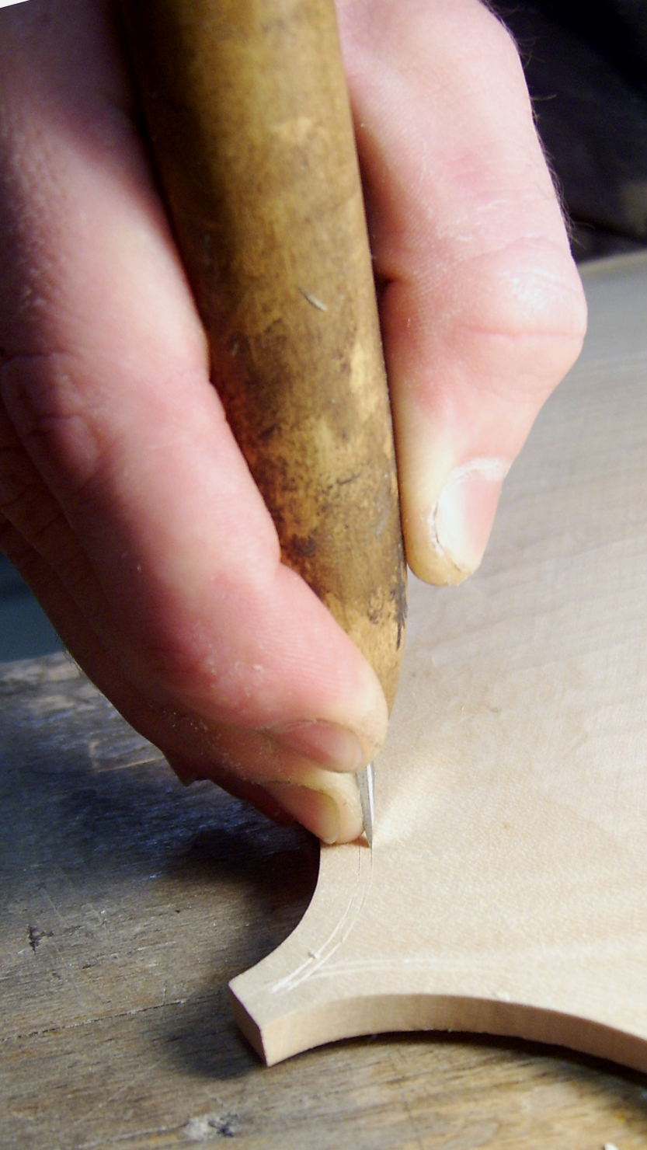
Our Past

The violin maker of former times invested all of his knowledge and skill, but also all of his love to produce an object of consummate beauty whose sole purpose, however, is to produce an incomparably beautiful musical sound.
These master craftsmen were well aware of the fact that the quality of sound their creations produced would mellow and refine with the passing of time, but none could have ever imagined that the violin leaving his shop at this very moment was about to embark on a journey that would last several hundred years. Nor could he have ever dreamt that a violinist of the 21st Century would still delight in the marvelous virtues that he had so lovingly implanted - several centuries ago - into this so tiny and so fragile wooden body. Nor that human ears some twenty generations later would rejoice at the elegant and eloquent sounds that his creation was still capable of producing. Or is it that the violin has eschewed the ravages of time to achieve a near immortality?

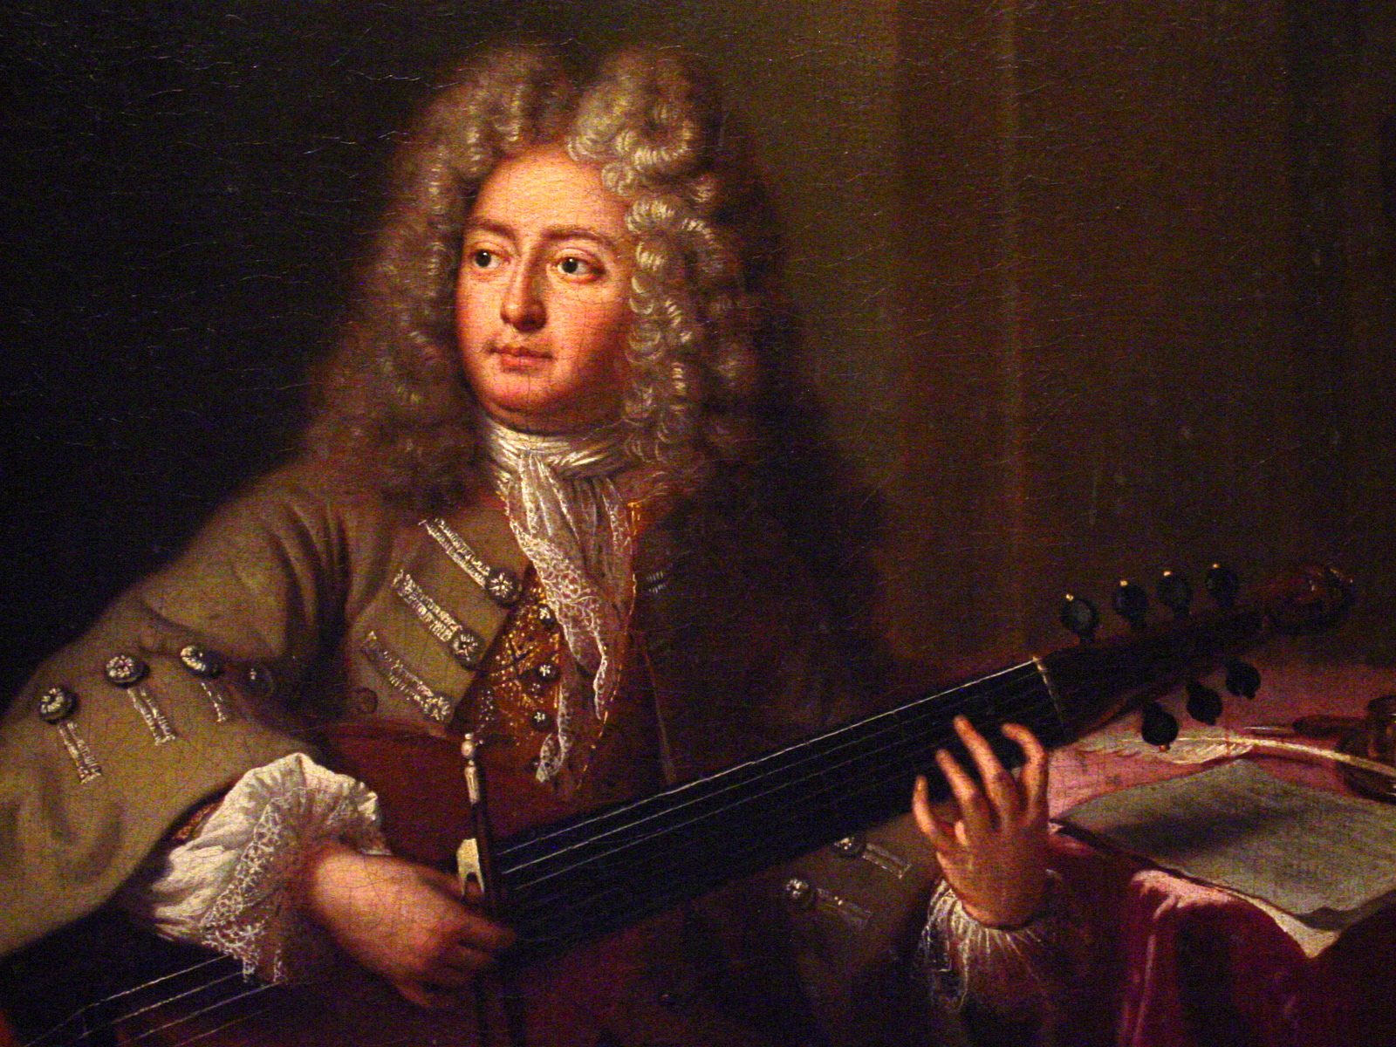
The composer of his time was doubtless inspired precisely by the marvelous sounds issuing from these finely crafted instruments to create musical masterpieces of profound emotional expression.
But he, too, could not have imagined that the fruits of his com-positional endeavours would be treasured by listeners hundreds of years in the future, that the most intimate thoughts and sentiments he skillfully clothed in musical phrases would reach out to touch the hearts and souls of so many future generations.
Our Present
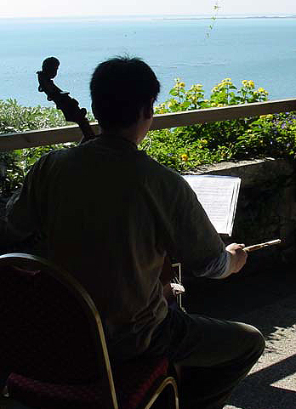
The professional musician and the student of today, if given the opportunity to work with such a fine instrument, acquire a knowledge about the aesthetics of the period in light of which the poetic masterpieces of those composers should be interpreted. This musician, now acquainted with the instrument and its music, is then in a position to present to the public of our day those exquisite compositions, performed on the very same instrument that a fine craftsman had created on his workbench three, perhaps even four hundred years ago. The craftsman and the composer have long perished, but their legacies live on, enriching the lives of musician and listener today as they enriched the lives of many along the way and will continue to do so for generations yet to come.

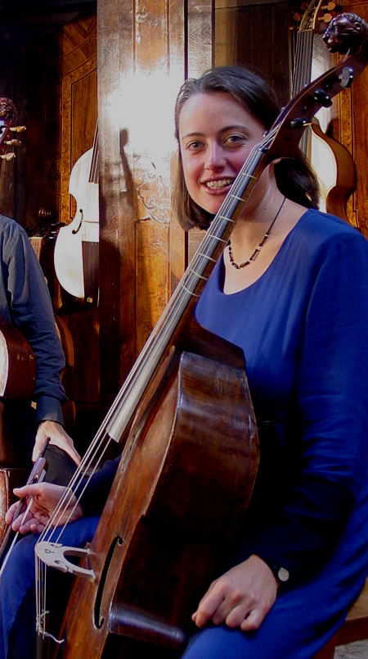
Our Mission for the Future

Upholding this tradition, unbroken since the violin left the atelier of its birth, is the mission which Orpheon has chosen to assume. The reception and the impact that both the exhibitions and the concerts with the historical instruments of the collection have enjoyed in the past proves that not just the musicians, but also the general public fully understand and appreciate the significance and the long-term implications of this quest.

We hope that you, too, will welcome these venerable ambassadors from a distant past into your heart. Lend them your ears, for theirs is the power to move your soul and change your life!
STILL ALIVE
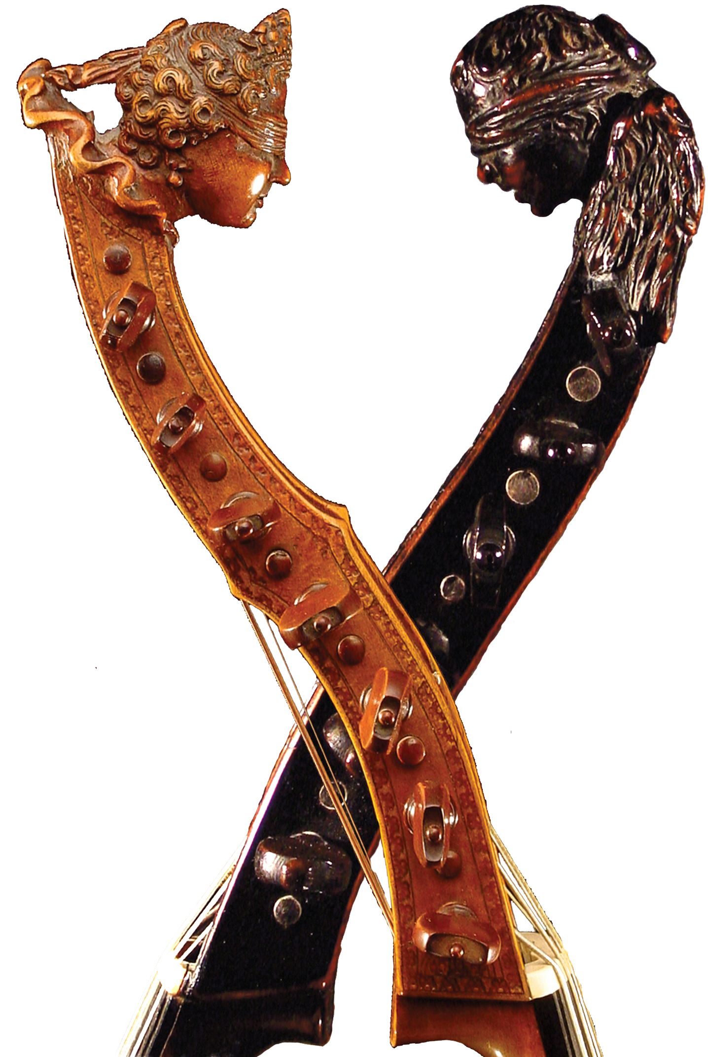
THE VÁZQUEZ COLLECTION
OF HISTORICAL STRING INSTRUMENTS
1560 – 1800
O R P H E O N F O U N D A T I O N
Praterstrasse 13-1-3, A-1020 Vienna
www.orpheon.org
The Viola da gamba Family

The Violin Family or Viola da braccio Family

The instruments which comprise the collection are grouped into these two main families. It is important to note that the two families - contrary to common opinion - are not related to each other: the viola da gamba is not at all a predecessor of the violin. They arose almost simultaneously and coexisted for a period of three hundred years.

The viola da gamba was born in the culturally heterogeneous region of Valencia, Spain at the end of the 15th Century. The first painting of a viola da gamba being played by an angel, found in Xativa (Valencia), dates from 1475-85. A photo of this painting is to be found in Hall 2. The instrument derived frets, the number of strings (six) and the tuning (in fourths, with a third in the middle) from the lute or the vihuela (a predecessor of the guitar). In essence, the viol, as the viola da gamba is called in English, is a bowed guitar. The playing position is on the knees or between the legs, therefore the name "da gamba", from the Italian word meaning "leg".

The violin descended onto Northern Italy in the hands of wandering minstrels most likely from Poland or the far North. The first paintings of a complete quartet of viole da braccio were painted by the exquisite Renaissance artist, Gaudenzio Ferrari and are to be found in the cathedrals of Saronno and elsewhere; these date from ca. 1535. These paintings are also to be seen at the exhibition (hallway leading to Room 4). The violin has commonly four strings and is tuned in fifths. There are no frets on the fingerboard. The violin is derived from the medieval vielle or rebec, both played on the shoulder, for which reason the Italians called it the "viola da braccio", meaning "arm-viola".

These two independent families lived and worked together in harmony for about 250 years. The viola da gamba disappeared gradually in the course of the 18th Century. The violin has come to represent the highest achievement of Western musical tradition. The morn symphony orchestra is based on the sound of this family of instruments.

The Viola da gamba Family
Like all instruments of the Renaissance, the viola da gamba came in all sizes, representing the different ranges of the human voice. These are called:
Treble viola da gamba (tuning: d",a',e',c',g,d)
Alto viola da gamba (historically very rarely used: c",g',d',b-flat,f,c)
Tenor viola da gamba (g',d',a,f,c,G)
Bass viola da gamba (d'.a,e,c,G,D)

Great bass viola da gamba (g,d,A,F,C,GG)
Double bass viola da gamba (d,a,e,C,GG,DD)

In addition to this, a smaller member was added in France in the 18th Century, the pardessus de viole, tuned one octave higher that the tenor (g",d",a',f',c',g), but sometimes having only five strings (g",d",a',d',g). All members of the viola da gamba family may be seen in this exhibition!

The Violin Family or The Viola da braccio Family

Violin (e",a',d',g)
Viola (a',d',g,c)
Violoncello (a,d,G,CC)
Double bass (g,D,A,EE and sometimes CC)

There were also several sizes which were used very seldom. One, the violoncello piccolo, is a four or five-string version, with an added upper string tuned to e'. Another, extremely rare, a five-string violin with variable tunings. All these members of the violin family are on display in this exhibition, too! We do not have a violino piccolo at this time, but we are looking for one!

The Viola d'amore

From the 17th to the beginning of the 19th Centuries, two other types of string instruments were also occasionally used. In the wake of the expansion of European hegemony, the discoveries in the Far East, principally in India and China, inspired the construction of musical instruments in Europe, as in the case of the sympathetic strings of the viola d'amore and the baryton.

The viola d'amore is a type of violin, but with six or seven gut strings on the fingerboard which are played with a bow, and another six or seven thin metal strings running under the fingerboard, which resonate when the upper strings are bowed and produce a magical, silvery resonance which manages to charm every listener. This special colour was used to express delicate and amorous sentiments, as the name foretells.

The Baryton

The baryton is essentially a viola da gamba with six or seven playing strings but with many thin metal strings running under the fingerboard, which however, can also be plucked with the thumb of the left hand while the other strings are bowed: a very amusing and delightful effect. Since Prince Esterhazy adored (and played) this instrument, his Capellmeister, Joseph Haydn composed a large body of magnificent works for the baryton.
Two viole d'amore and one baryton are displayed in this exhibition!

The Collection of Original Bows

The history of the bow is thoroughly documented by the original bows in the collection as well as by copies of historical bows, where no original is to be found. Since 1500 the bow has undergone significant transformations, which influence to a high degree the performance of the artist on his instrument. In fact, a bow can totally transform the sound of a viol or a violin, something which few know.

The Visual and Acoustical Documentation

Another important aspect of the work of the Orpheon Foundation is the recording of the sonorous heritage the collection represents in the form of compact discs, catalogues, postcards, which are available at the door. There are recordings of the viola da gamba consort, the Trios by Haydn and Lidl and the monumental double-choir motets by Johann Ludwig Bach, recorded with nine violas da gamba of the collection.

These may also be ordered via our web site, which you may wish to recommend to interested friends. We are also interested in bringing this collection to other cities and other countries and would therefore be very thankful for your recommendation.
www.orpheon.org
ON THE VIOLA DA GAMBA

“If one were to judge musical instruments according to their ability to imitate the human voice, and if one were to esteem naturalness as the highest accomplishment, so I believe that one cannot deny the viol the first prize, because it can imitate the human voice in all its modulations, even in its most intimate nuances: that of grief and joy”
(Marin Mersenne, Harmonie Universelle, 1636)

Thus praised the French theoretician Marin Mersenne in 1636 the viola da gamba*, this most noble of all string instruments, which graced during its flowering - from 1480 to 1780, i.e. from the Renaissance to the Classical Period - court, church and chamber with its presence. Because of its delicate sound, rich in harmonics and in subtle inflections, the viol was considered the most perfect imitator of the human voice, which, in the wake of humanism, had been elevated to be the measure of all things musical, and therefore became a paramount medium for sophisticated music.

Baldassare Castiglione -“Il Libro del Cortegiano” of 1528 - considers the playing of viols indispensable for the education of a nobleman:

“Music is not just a decoration, but a necessity for a courtier. It should be practiced in the presence of ladies, because it predisposes one to all sorts of thoughts... And the music of four viole ad arco is very enchanting, because it is very delicate, sweet and artfull.”

Spellbound by the ideas of Italian Humanism, the art-loving princes Francis I (†1547) and Henry VIII (†1547) brought not just the leading Italian painters, sculptors and thinkers, but also Italian composers and musicians to France and to England respectively. At the time when Neo-Platonic Thought was in everyone's head, Petrarca and Ariosto in everyone's mouth, the viola da gamba was in everyone's hand!

Postlude:

We had our Grave Musick, Fancies of 3,4, 5 and 6 parts to the Organ, Interpos’d (now and then) with some Pavins, Allmaines, Solemn and Sweet Delightful Ayres; all which were (as it were) so many Pathettical Stories, Rhetorical, and Sublime Discourses ; Subtil and Accute Argumentations, so Suitable, and Agreeing to the Inward, Secret, and Intellectual Faculties of the Soul and Mind ; that to set Them forth according to their True Praise, there are no Words Sufficient in Language ; yet what I can best speak of Them, shall be only to say, That They have been to my self, (and many others) as Divine Raptures, Powerfully Captivating all our unruly Faculties, and Affections, (for the Time) and disposing us to Solidity, Gravity, and a Good Temper, making us capable of Heavenly, and Divine Influences.
Tis Great Pity Few Believe Thus Much, but Far Greater, that so Few Know It.

(Thomas Mace, Musick's Monument, 1676)

ON THE VIOLIN OR THE VIOLA DA BRACCIO
A quoy l'on peut adjouster que ses sons ont plus d'effet sur l'esprit des auditeurs que ceux du Luth ou des autres instrumens à chorde, parce qu'ils sont plus vigoureux & percent davantage, à raison de la grande tension de leurs chordes & de leurs sons aigus. Et ceux qui ont entendu les 24. Violons du Roy, advoüent qu'ils n'ont jamais rien ouy de plus ravissant ou de plus puissant: de là vient que cet instrument est le plus propre de tous pour faire danser, comme l'on experimente dans les balets, & partout ailleurs. Or les beautez & les gentillesses que l'on pratique dessus sont en si grand nombre, que l'on le peut preferer à tous les autres instrumens, car les coups de son archet sont parfois si ravissans, que l'on n'a point de plus grand mescontentement que d'en entendre la fin, particulierment lors qu'ils sont meslez des tremblemens & des flattemens de la main gauche, qui contraignent les Auditeurs de confesser que le Violon est le Roy des instrumens.
…ceux qui jugent de l'excellence des airs & des chansons, ont des raisons assez puissantes pour maintenir qu'il est le plus excellent, dont la meilleur est prise des grands effets qu'il a sur les passions, & sur les affections du corps & de l'esprit.

One may add that its sounds have a greater effect on the spirit of the listeners than those of the lute or other string instruments, because they are more vigorous and are perceived the better due to the great tension of their strings and their high range. And those who have heard the 24 Violins of the King avow that they have never heard something more ravishing and powerful. From this one deduces that this instrument is the most proper to make one dance, as one experiences in the ballets and everywhere else. In addition the beauties and the gentilesses that one employs are so numerous, that one could prefer it to all other instruments, because the strokes of its bow are at times so ravishing, that one suffers no greater displeasure than when they cease to play. Particularly when (the sounds) are joined with trills and vibrato of the left hand, which conduce the listeners to confess that the Violin is the King of instruments.

…those who judge the excellency of airs and chansons have reasons sufficiently powerful for maintaining that it is the most excellent, wherein the best reason is the great influence that it exercises on the passions and the affections on the and soul.

Marin Mersenne, Harmonie Universelle, 1636

The Viola da gamba Family

The viola da gamba is not a predecessor of the violin, but is a completely different family altogether. It first appeared in Valencia, ca. 1470 - 1480 and was in vogue until about the French Revolution, although some still played the viol until 1800. Unlike the violin, whose form was already firmly standardized by the middle of the 16th C., the viola da gamba was built in a wide variety of shapes and forms: no standard model was ever attained nor striven for. Indeed the divergences in construction principles during the period from 1480 to 1780 yielded remarkably different acoustical results, so that one cannot really speak of "the" viola da gamba. An Italian viol of the Renaissance has literally very few things in common with, say, an English Tudor viol or a French viol serving His Majesty in Versailles. Each instrument has thus to be examined individually. But this is the exciting thing about this multifaceted "family" of instruments which you are about to get to know…

The viol was an outspokenly aristocratic instrument; as it formed an integral part of the education of a gentleman, like lute, harpsichord, singing. It was used principally for serious music in cultured surroundings, as opposed to the violin, which in the beginning was used by professional musicians and minstrels for accompanying dancing and entertainment and thus was not considered suitable for persons of gentle breeding.

The Viola da gamba in Consort Music

In the Renaissance, all instruments were built in families, representing the ranges of the human voice: Soprano, Alto, Tenor, Bass. The viol consort was made up of instruments of different sizes: treble, tenor and bass being the most common. Two trebles, two tenors and two basses constituted a "chest of viols", which would ideally have been built by the same maker, although the literature for consort counts works of from two to up to seven players. Due to its delicate, rich and finely nuanced tone, the viol was employed preferentially in polyphony, either in combination with voices (motets, madrigals, chansons) or in the instrumental forms derived from these vocal models (ricercare, canzona, tiento, fantasia). It is principally in the Fantasia - the polyphonic form par excellence - that the greatest English masters - Byrd, Ferrabosco, Coperario, Lawes, Gibbons, Purcell - excelled: the most erudite thoughts, the most sublime poetry found expression here. In quality, these works cannot only be favourably compared with the very best in the poetical and theatrical genres of their English contemporaries, but also with the best of chamber music of all periods.
When therefore Mersenne wished to demonstrate the style of music suitable for the viola da gamba, he chose to print a six-part fantasia by Alfonso Ferrabosco!
The Family of the Viola da Braccio
Violin, Viola, Violoncello, Violone or Double bass
1 - Violin – probably Brescia, 16th Century
This violin shows all of the typical characteristics of the work of Andrea Amati (ca. 1505-1577), one of the most illustrious violin-makers of all times. But although the contours of the body and of the sound holes exactly match those of Amati, the violin is most likely a contemporary copy of Amati. It may be rightfully claimed that Andrea Amati single-handedly created the violin in its present form, which has remained unaltered since the 16th C. Recent investigations have revealed that Andrea Amati, who signed his first labels as “Amadi”, may have been a Spaniard of Arabian descent (Andreas Hamad), whose family may have been expulsed during the fanatical religious persecutions from his native Valencia to Italy. Welcomed by the open and free spirit of the Venetian Republic, he eventually settled in Cremona to found the Art of Violinmaking as we know it today. Amati’s instruments demonstrate a level of artistic excellence which can be compared to the achievements in painting, sculpture, architecture and literature of the Era of Humanism.
Our violin resembles closely the Amati model, although the work on the scroll and pegbox point rather towards Brescia. We thank Andrew Dipper, an English expert, for the attribution.
2 - Violin - Nicolò Amati - Cremona, 1669
The Dynasty founded by Andrea, which standardised violin making, was carried on by his sons and reached a pinnacle in the perfect form of Nicolò Amati (1596-1684). Nicolò also was responsible for educating a whole generation of outstanding violin makers, among which were Andrea Guarneri, Alessandro Gagliano, Giovanni Battista Rogeri and perhaps also Jakob Stainer. Remarkably the instruments of Nicolò Amati and Jakob Stainer remained the most coveted ones throughout the 17th and 18th Centuries. The fashion for Stradivarius arrived only towards the end of the 18th and the beginning of the 19th Century. The violin by Amati in our collection sounds singularly good. It is a great pleasure to have an instrument by this maker in the collection: one would wish for more!
The University of Hamburg has carried out dendrochronological studies (see materials in the exhibition) on the wood of this violin. Dendrochronology is the science of determining the date of the annular rings in pine or spruce, serving to establish when the tree was felled. Dr. Peter Klein and Dr. Micha Beuting have established that the rings on the top of the Amati run from 1489 until 1658, indicating that the tree was felled in or about 1659. Since the label bears the year 1669 and since violin makers usually wait a few years to let the wood dry, then it is very much believable that the violin could very well have been made in 1669 by Amati.
3 - Violin - Carlo Giuseppe Testore - Milano, ca. 1700
The Testores were a notable dynasty of gifted violin makers in Milano. They lived on the same street, even in the same building, as the Grancinos and the Pastas. This violin remains in the so-called morn condition, which means that the neck has been tilted back a bit, the bass bar is thicker and it is strung with metal strings. The violin is lent out regularly for soloists and students of the Vienna University.
4 - Violin - Matthias Albanus - Bozen, ca. 1680
This master from Tyrol reached the stately age of 99, which explains why his style underwent some modifications along the way. Basically he worked along the lines of Jakob Stainer and Nicolò Amati. The scroll on this violin is particularly beautiful, the back is finely modelled, the red varnish shows signs of cracquelé, a typical sign of his work. Arcangelo Corelli owned and performed on one of his violins.
5 – Violin – Antonio Pollusca – Roma, 1741
The place of honour of the list should be given to this violin, the very first baroque violin of the present collection, which I purchased right at the beginning of my university studies - 1969 - in Chicago, directly from Mr. Kagan (Kagan & Gaines).
One encounters the following text in Lütgendorff:
"Dem Namen nach ein Böhme und auch seiner Arbeit nach mit der Prager Schule verwandt, wenn er auch unter Tecchlers Einfluß stand. Er ist nur wenig bekannt, gehörte aber jedenfalls zu den besseren römischen Geigenmacher seiner Zeit."
Translation: "According to the name, a Bohemian maker; his work is related to the Prague School, although he stood under the influence of Tecchler. He is very little known, however he belongs to the better Roman violin makers of his time."
The peg box and scroll betray his Roman heritage: they arose under the influence of the most significant masters of the city, David Tecchler. The sound holes remind one of the work of Francesco de Emiliani, a maker also active in the Eternal City.
6 - Violin - Giovanni Antonio Marchi - Bologna, 1740-1795
A very fine Bolognese luthier in the tradition of Guidantus, Tononi, Faccini. Interestingly, these violin makers worked under the influence of Stainer rather than that of their Cremonese contemporaries. Gian Antonio Marchi wrote a treatise in 1786, now preserved in Bologna, on how to set up a violin, which is a valuable source for technical details on construction.
Ottorino Resphigi owned and played on a violin of this Bolognese master, which closely resembles our instrument.
7- Violin – Jakob Horil, Roma, ca. 1750
Jacob Horil was a native of Bohemia, resided in Viennna from 1720 onwards and settled down in Rome ca. 1740. His style retains the overall characteristcs of his Northern Provenance, abstaining from incorporating Italianisms..As a matter of fact, this violin, with its swung scroll and short, round sound holes is remniscent of the work of the Viennese School, leading some experts to doubt the certification.
8 – Violin – probably German, 19th C. (Previously thought to have been of the School of Gofriller)
9 - Violin - Italien - Cremona or Venice, ca. 1700
The opinions of the experts vary on this violin: Cremona, Venice or even Austria.
10 – Violin – Milanese School (North Italy ca. 1700)
This violin has now been identified to be of Milanese origin by the expert from Cremona, Eric Blot, on his visit to the collection in Vienna.
11 – Violin – Sebastian Dallinger, Vienna, ca. 1780 (label Jacobus Stainer, Absam 1675)
Although endowed with all of the constructional characteristisc of the Stainer instruments, this violin was made by Sebastian Dallinger, sometime in the 18th C. The sound is quite remarkable. Ludwig van Beethoven owned and played on an instrument by this maker.
12 – Violin –Johann Christoph Leidolff, Wien, 1739
13 – Violin –Johann Christoph Leidolff, Wien, 1745
14 - Violin - Johann Christoph Leidolff - Wien, 1747
The Leidolff Family was one of the most significant in the Vienna of the 18th Century. To judge from his work, the founder of the Dynasty, Nikolaus, most likely studied inn Italy: his work shows the influence of Ruggieri in Cremona. Nikolas made the fabulous violoncello from 1690 (Nr. 61), the magnificent basse viola da gamba (Nr. 105), and the splendid viola (Nr. 40), which carries the ettiquette of his son, but most likely was build by Nikolas. Johann Christoph, his son, was also a notable violin maker: four of his violins and a violoncello are in the collection. The two violins (14, 15) are veritable twins, made from the same wood, the same varnish at the same time.
15 - Violin - Johann Christoph Leidolff - Wien, 1748
This violin is in its original state, bearing the original neck, fingerboard, bass bar. Only the bridge and tailpiece have been replaced.
16 – Violin – Joseph Ferdinand Leidolff – Vienna, 1767
17 - Violin - Johann Georg Thir – Wien, 17..
Johann Georg Thir (ca. 1710-1779), a native of Füssen in Allgäu, is judged to be the finest violin maker in the Vienna of the 18th C. His excellent work are in no way inferior to that of his Italian contemporaries. The collection has a violin, a viola, a violoncello and a trully magnificent five-string bass.
18- Violin – Mathias Thir – Vienna, 17__

19 – Violin – Johann Joseph Stadlmann, Wien 1768
Johann Joseph (1720-1781) was the son of Daniel Achatius Stadlmann (ca. 1680-1744), the founder of this distinguished Viennese dynasty of luthiers in the 18th C. In fact, Daniel Achatius was entrusted with the Imperial monopoly on the wood trade for the guild of luthiers, which explains why the instruments of this Family were constructed from the finest, first-choice materials.

20 - Violin - Johann Schorn - Salzburg, 1707
While still living in Innsbruck, Johann Schorn (1658-1718) received commissions, as had Jakob Stainer somewhat earlier, for instruments from the Archbishop of Salzburg, Max Gandolph von Kuenburg (1668-1687), an enlightened aristocratic clergyman, generous patron of the arts, whose ambitious programmes transformed the city into a center for Baroque art, architecture and music of unparallelled brilliance. It was he who summoned Heinrich Ignaz Franz Biber and Georg Muffat to his service. On the recommendation of the Capellmeister Matthias Biechteler (ca. 1670-1744) Johann Schorn was appointed Court Violin Maker (Hoff Lauten- und Geigenmacher) in 1713, transfering his workshop to Salzburg. The influence of his Innsbrucker colleague, Jakob Stainer is so evident in Schorn's works, that his violins could easily pass for that maker's creation. His sons, Johann Paul and Johann Joseph, maintained the very high quality of violin making in Salzburg into the 18th Century.

Working together with Heinrich Biber, Johann Schorn supposedly may be rightfully credited with having invented the viola d'amore. Indeed his instruments may be considered the finest of them all. One of his violas d'amore is to be found in our collection. Although bearing the label of Johann Christoph Leidolff, that viola d'amore could hardly be by anyone else but Johann Schorn.
Wolfgang Amadeus Mozart owned and played on a violin by Johann Schorn . Ludwig van Beethoven owned a Salzburg violin from around 1700, at present in the Museum in Bonn, which, although bearing no label, resembles very closely the violins of this master and his sons.
21 - Violin - Tyrol, 18th C.
22 - Violin - Tyrol, 18th C.
23 – Violin – Aegidius (I) Kloz (I), Mittenwald, 1717
24 - Violin – Aegidius (II) Kloz, Mittenwald, 1774
Mittenwald , together with Füssen, those two small cities in South Bavaria near the Alps, became the centers of violin making in Germany, a position held by these two cities until the present. The leading family in Mittenwald was named Kloz, which brought forth outstanding makers. The collection has one violin each from Sebastian, Aegidius I and Aegidius II.
Aegidius Kloz (1733-1805), one of the most outstanding of the German Masters, adheres closely but not slavishly to the general norms of Stainer, just like the majority of the excellent luthiers of this extensive violin-making dynasty from Mittenwald, which profoundly influenced the development of the violin North of the Alps. The varnish, golden and translucent, is of very high quality. The work on the scroll and peg box can be counted to be among the finest on a German violin.
25 - Violin - Sebastian Kloz, Mittenwald, 1733
26 - Violin – Martin Leopold Widhalm, Nürnberg, um 1760
Leopold Widhalm (1722-1776) was a native of Vienna, but settled in 1745 Nürnberg, where he remained the rest of his life. This violin is particularly good condition, retaining most of its red varnish, quite rare for these violins.
27 - Violin - Joseph Hill - London, 1774
Joseph Hill was the founder of the most famous violin maker dynasty in England, whose members are active even to this very day. This violin was fashioned after the Amati-model, so cherished in England.
28 – Violin – Johann Anton Gedler, Füssen, ca. 1790
The joy of experimenting with exotic forms of some of the South German luthiers is well evident in this example. Even more extravagant variants than this are known from this school, some with heads of lions, dragons and griffiths. Although rare today, many such instruments appear in paintings of the 16th and 17th C..
29 – Violin – Alemannisch School
The Alemanisch School, also known as the Black Forest School, was an independent branch of the Art of Violin-making noted for its flamboyant ornamentation, very often all over the body of the instrument, as in our example. The intarsia or inlay work utilises woods of different coloration, giving the impression that the design has been painted. The Alemanisch School was prevalent in the regions between the Black Forest of Southern Germany and the Alpine regions of Switzerland and Austria (the region populated by the Alemanen Tribes) between the beginning of the 17th Century to the first part of the 18th, when this style suddenly disappeared, perhaps englobed by the established violin-making centers of Mittenwald, Füssen and northern Italy. In spite of the profuse ornamentation, these instruments sometimes have a remarkably good sound. This one does not, but perhaps due to the many vicissitudes it experienced during its long life.
30 – Violin – Anon. Master Prague
31 – Violin - Anon. Germany
32 – Violin – Johannes Uldaricus Eberle, Prague, 1758
33 – Violin – Jacobus Koldiz, Rumburgue, 1751
34 - Violin - Deutsch – 18th C.
35 – Anon. Mittenwald
36 – Anon. Klingenthal, end of the 18th C.
37 - Violin – five-string - Joachim Tielke - Hamburg, um 1700
This five-string violin shows the typical characteristics of the instruments that Tielke bequeathed to the world. It is in perfect state of preservation. Notable on the violin: the ivory border inlay on the top and back, the lion’s head, which reminds one of the galleon figures of Hanseatic ships and the flowers and ivy decoration of the pegbox. A few composers wrote specifically for the five-string violin, among them Emperor Leopold I from Austria. The tuning was probably: a-e-a-e-a or g-d-g-d-g.
Whether Tielke actually constructed instruments or whether he was only a dealer, selling other makers’ products is not settled so far. The fact is, however, that his reputation was very high throughout the world, even long after his death. Tielke also made the fabulous bass violas da gamba (Nr. 108, 154).
38 –Violin with five strings: “Quinton” - Louis Guersan - Paris, um 1740
This instrument has nothing in common with the German-Austria five-string violin (Nr. 37). We are dealing with a completely new invention here, which arose in France around 1710 and fulfilled completely different tasks. The tuning is like a violin below (g-d-a) and like a viol above (a-d-g), and held between the legs, this instrument allows an noble person to perform the repertoire of the violin with ease. Mme Henriette de France, daughter of Louis XV, was proficient on this and also the pardessus de viole.
39 - Viola - Milano, 17th C.
Certificates by Hill and Machold. This viola suffered a surgical operation during the 18th or 19th C., reducing the original body by perhaps 3 to 4 cm, a fate suffered by almost all large violas and violoncelli from the 17th century. This reduction was made in order to facilitate playing. Even the celli by Stradivarius were reduced from 77-79 cm to the now standard 75 cm. Our viola measures now 41.8 cm; it was probably 44 cm long.
40 - Viola – Nikolaus Leidolff (um 1650 - um 1710)
Ettiquette: Johann Christoph Leidolff - Wien, 1719
Whether this splendid viola was made by the father, Nikolas or by his son is not certain. The son possibly set his ettiquette in the instrument after the death of his father. The back was described by Daniel Draley as “One of the finest backs I have ever seen outside of Italy”. According to him, it reminds one of the work of Vincenzo Ruggieri, thus substantiating the theory that Nikolas learned his trade in Cremona.
Nikolaus Leidolff saw the light of day in 1650 in Milano, then learned his trade in Italy. After his journeyman’s years in Italy and Switzerland, he settled in Vienna, married the widow of his Master, Isaak Ott from Füssen in 1672 and took over the workshop. The quality of his work and the excellent sounds of his instruments earned him an international reputation way beyond the frontiers of the Habsburg Empire. His son, Johann Christoph, and his grandson, Joseph Ferdinand, carried on the family tradition until the end of the 18th C.
41 - Viola - Johann Georg Thir - Wien, 17__ (See Violin: Nr. 17)
42 – Viola - Mathias Thir, Vienna, 1786 (See violin Nr. 17)

43 – Viola - Johann Joseph Stadlmann, Vienna, 1764 (See Nr. 19)
Johann Joseph (1720-1781) was the son of Daniel Achatius Stadlmann (ca. 1680-1744), the founder of this distinguished Viennese dynasty of luthiers in the 18th C. In fact, Daniel Achatius was entrusted with the Imperial monopoly on the wood trade for the guild of luthiers, which explains why the instruments of this Family were constructed from the finest, first-choice materials.
44 - Viola - Sebastian Dallinger - Wien, ca. 1780
This viola is in original condition, bearing the maker's neck and fingerboard. It was never changed in the 19th C. Ludwig van Beethoven owned and played a viola by this renowned Viennese luthier.
45 – Viola – Tyrol, 17th C.

46 – Viola – Hulinsky, Prague, 1768
47 – Viola – Josephus Antonius Laske, Praha, 1787 (1738-1805)
Laske, Josef Anton Laske, born in Rumburg in 1738, died in Prague in 1805, was a pupil of Jacob Koldiz and Thomas Hulinzky. Laske worked in Dresden, Berlin, Vienna and Brunn, before returning to Prague. In addition to excellent violins, Laske also made pochettes, violas d'amore, harps and mandolins. According to Fetis, in Poland and Bohemia Laske enjoyed the reputation of being even better than the Italians. This viola is a fine example of his work.
48 - Viola - Deutsch – um 1700.
This viola has fortunately retained its original size, 44 cm., typical of violas of the 17th Century.
49 - Viola - William Smith - Sheffield, um 1780
Here we have another instrument in perfect original state, a prime example of violin making in England in the second half of the 18th C. All parts are original, no damage to front or back. Only the bridge and tailpiece have been replaced. The small dimensions of this viola made it suitable for chamber music in the salons. Johann Christian Bach Carl Friedrich Abel and others would have employed such an instrument in their performances.
50 - Viola d’amore - Jean Baptiste Deshayes Salomon - Paris, um 1740
This viola d’amore by one of the finest Parisian luthiers has seven playing and seven sympathetic strings. These last are accessible to the bow, but simply resonate freely when the upper strings are bowed, yielding a magical, endearing, otherworldly sound, which gave the instrument its name: the love-viola.
Our instrument, which was purchased at Sotheby’s London, is in perfect and impeccable original condition, even with the original pegs.

51 – Viola d’amore – Mathias Fichtl, Wien, 1711
52 - Viola d’amore - Johann Schorn, Salzburg, um 1700
(signed: Johann Christoph Leidolff - Wien, 1750)
This instrument represents the original model for the viola d’amore, with six bowed and six sympathetic strings. Johann Schorn apparently worked closely with the Salzburg Capellmeister Heinrich Ignaz Franz Biber to invent the viola d’amore. Consequently our instrument may well be one of the earliest violas d’amore in history, probably made sometime before 1700! The instrument is in its original state, including the original pegs, fingerboard, tailpiece and even quite probably some of the original strings.
A violin by Johann Schorn is also in the collection (Nr. 20): Wolfgang Amadeus Mozart played on a violin by Johann Schorn.
53 – Viola d’amore – Joann Joseph Hentschl, Brünn, 1750
54 – Viola d’amore – Thomas Andreas Hulintzky, Praha, 1774
55 - Viola d’amore - Michael Andreas Partl - Wien, 1751 ?
56 – Violoncello – North Italian, ca. 1760
Although judging from the sound this instrument is one of the finest in the collection, the experts are in disagreement as to its origin. Eric Blot (Cremona) claims that the wood used for the back and ribs is a particular species of maple from the Appennine Mountains in central Italy called oppio, thus corroborating the attribution to North Italy ca. 1720 by Charles Beare (London). Nevertheless other experts have claimed to identify the wood of the back as one of the following: oppio, carpino, willow, cherry, pear or apple. All of these woods are known to have been used for the construction of violoncellos and basses.
Label (probably fictitious): Ramon Fernan / dez Oviedo 1640
The spurious label, identifying this instrument as a Spanish production (city of Oviedo) from the middle of the 17th Century, can be dismissed on the basis of the results of dendrochronology. The youngest ring on the belly comes from the year 1755, yielding a problable date of construction of 1758-60.
57 - Violoncello - Simone Cimapane - Roma, 1692
Proof has been given, that this violoncello was played in the Orchestra of Arcangelo Corelli in Rome! Dr. Agnese Pavanello, a musicologist from Rome, who wrote her dissertation on Corelli’s orchestra, informed me that both Simone Cimapane and his son were members of Corelli’s orchestra. In addition, Simone also made instruments. Therefore it is a particular honour to have this violoncello in the collection, which once took part in performances with the great master. If only it could speak words…!
This cello is also discussed in the Dictionnaire Universel des Luthiers by René Vannes. He claimed that the Roman luthier Leonori had a violoncello by Cimapane of the year 1692. I purchased this cello from Mrs. Leonori, niece of the violin maker!
The violoncello was not reduced in size; the back measures 77 cm., which is typical for orchestral celli of the 17th C. It has a rosette in an unusual form, rather rare in violoncelli.
58 – Violoncello after Montagnana, Venice, ca. 1700
Domenico Montagnana was one of the most renowned luthiers in Venice, besides Cremona, one of the most important violin making centers in Italy. This cello, although not by him, clearly stands under the influence of the master. One of the characteristics of the school was the broad upper bouts, which yields a very full sonority.
60 - Violoncello piccolo – North Italy (Veneto), ca. 1700
The five string violoncello piccolo was used often for solo work in the Baroque. Among others, Johann Sebastian Bach and Georg Philipp Telemann dedicated works to this instrument. The highest string is tuned to e’. The wood of the back came from the roots of the tree, thus showing a somewhat extraordinary pattern. Charles Beare, one of the leading experts on the violin, was quite fond of this violoncello.
61 - Violoncello - Nikolaus Leidolff - Wien, 1690
Nicolaus Leidolff (ca.1650-ca.1710) Born near Milano around 1650, Nicolaus Leidolff first learned violin-making in Italy. After traveling as an apprentice in Italy and Switzerland, he settled down in Vienna, initially employed by Isaak Ott, one of the many luthiers from Füssen who established himself in Vienna. As was the custom of the times, Nicolaus Leidolff married the widow of his employer upon his death in 1672, taking over his master's workshop. The high quality of his workmanship and the excellent sound of his instruments very soon won him an international reputation far beyond the borders of the Habsburg Empire. His son, Johann Christoph and his grandson, Joseph Ferdinand, carried on the family tradition to the end of the 18th C. Our violoncello retains the original dimensions of the body, which enables it to produce the full, generous, sonorous bass necessary for a Baroque orchestra.
62 - Violoncello - Anton Posch - Wien, ca. 1700
It is very rare to encounter a violoncello in the original dimensions. With a back of 81.1 cm, this violoncello is the largest in the collection, possibly one of the largest all around! As mentioned before, most large celli were reduced to the length of 75 cm considerd the standard today. A fifth low string was added to the instrument, a GG or FF string (as described in Syntagma Musicum by Michael Praetorius 1619), which allows the occasional playing of the lower octave (16’ range).
63 - Violoncello - Johann Georg Thir - Wien, 17.. (See Violin Nr. 17)
Johann Georg Thir (ca. 1710-1779), a native of Füssen in Allgäu, is judged to be the finest violin maker in the Vienna of the 18th C. His excellent work are in no way inferior to that of his Italian contemporaries. The collection has a violin, a viola, a violoncello and a trully magnificent five-string bass by J. G. Thir. His brother, Matthias Thir, also an excellent luthier, made a violin and a viola in original condition in our collection.
64 - Violoncello - Michael Ignaz Stadlmann - Wien, um 1780
Michael Ignaz was the son of Johann Josephs (1720-1781), who was the son of Daniel Achatius Stadlmann (ca. 1680–1744), the founder of this significant Viennese dynasty Daniel Achatius was given the monopoly wood in the Habsburg Empire, which is why the instruments from this family have the most wonderful wood for building their instruments. There is one violin and one viola by Johann Joseph in the collection.
65 - Violoncello - Johann Christoph Leidolff - Wien, um 1750 (See Nr. 15)
66. Violoncello, Anon. Vienna, ca. 1780
.
67 – Violoncello piccolo, German, ca. 1800
This violoncello retains its original set-up, constituting thus a valuable document to the construction principles of the times. It was probably tuned to G-d-a-e'.
68 - Violoncello piccolo by Carlo Giuseppe Testore, Milano, ca. 1700
This is a very recent acquisition. A very fine example of the work of this Milanese master
69 – Violoncello after Andrea Amati by Roland Houël, Mirecourt, 2007
This is an exact reconstruction of the original dimensions of the Andrea Amati violoncello in the Shrine to Music Museum, which suffered an attrocious alteration in size. The scientiific research which this reconstruction entailed may be seen on the television screen next to this instrument: it was presented as a lecture in Cremona in 2006, attended by 200 violin-makers from all over the world at the exhibition dedicated to the works of Andrea Amati.
70 – Violone, six-string in D, Veneto, 17th C.
This is the largest member of the viola da gamba family, tuned one octave lower than the bass viola da gamba: DD-GG-C-E-A-d. This type of double bass or violone would have been in use throughout the 17th C.
71 – Violone (Double bass) with 5 strings - Johann Georg Thir - Wien, 1750
This violone or double bass merit our attention. As a rule, double basses are made from low quality woods, the finer planks saved for the more expensive violins and violoncelli. This bass, however, has the finest highly-figured spruce for the top and extremely highly figured maple for the sides and back. The fact that the leading luthier in Vienna was given the commission for a contrabass and that he used the finest spruce and maple available imply that this was a special order from some very wealthy customer, either the Emperor himself, or Prince Esterhazy, who at the time was the wealthiest man in Europe, or Graf Lobkowitz, who kept a solid musical establishment in his palace.
72 - Violone (double bass) with 4 strings - Johannes Udalricus Eberle – 1750
This imposing double bass, which because of its size and the mean quality of the material probably was in the service of a large church in the Habsburg Empire, came in intact condition into the collection. Even the neck, tailpiece and the tuning-machines are original. The bridge and strings have been replaced! The wood used in its construction is very plain, which probably indicates that it was destined rather for use in the musical establishment of a church rather than at court. Indeed the generous dimensions of this instrument would also point to its use in a large space. The sound of this double bass is so rich, so full and majestic that it can easily completely metamorphose a 40-man orchestra. The sound holes are in the form of snakes or flames, typical of the Austrian – South German Region.
73 – Violone, 6-strings in G, German, 18th C.
This is a member of the viola da gamba family. Larger than a normal bass viol, it is usually refered to as "great bass viola da gamba" (Praetorius: Groß-Baß-Viola da gamba; in England: great bass viol). The tuning is usually: GG-C-E or F-A-d. It was one of the most frequently used violones during the 16th and 17th Centuries, in church and chamber alike. Our violone, a particularly excellent example of this instrument, has often been used for recordings.
The Family of the Viola da Gamba
Treble, Tenor, Basse viola da gamba, Pardessus de viole, Violone, Baryton
74 - Treble viola da gamba 1 - William Turner - London, 1647
75 - Treble viola da gamba 2 - William Turner - London, 1656
76 - Treble viola da gamba 3 - William Turner - London, um 1650
Since we are dealing with a luthier of the 17th C., then one should be very pleased to have four instruments by William Turner in our collection. The theoretician, Thomas Mace, recommends in 1676 that one should assemble a viola da gamba consort from instruments by the same maker, that are at least 100 years old. The age, he admonishes, improves the quality of the sound of string instruments. We have taken his advice seriously!
77 – Treble viola da gamba, Henry Jaye, London, ca. 1620
Henry Jaye is considered to be one of the most outstanding makers of viols in Jacobean England, particularly suited for the performance of the viol consort repertoire. Having been transformed into a viola, this instrument was restored as a viol by Jan Stejskal, who also provided the photographic documentation of his work, seen on the screen.
78 – Treble viola da gamba, Munich, 17th C.
Although this small treble viol most likely came from Munich, the head, in form of a dragon, is a reproduction of one by Joachim Tielke.
79 - Treble viola da gamba - Leonhardt Maussiell - Nürnberg 1720
A treble viola da gamba in very excellent state of conservation by Maussiell, one of the leading violin makers in Nürnberg. Many composers wrote music for this type of treble viol, sometimes called “violetta” in Germany, among them, Telemann, Molter, Finger, Schwarzkopf.
80 - Treble viola da gamba – In Festoon - Form I - um 1730
81 - Treble viola da gamba - in Festoon - Form II - um 1730
One finds this very curious form in Italy, Austria, Germany, Holland and England. Nr. 80 was bought in Spain around 1980. I bought the second one in 1998 in Bonhams London, thinking that it was a twin to the first one. Many years later the dendrochronological investigations of the University of Hamburg proved that the wood from the tops of the two instruments not only were from the same time, but also from the same tree!
82 – Treble viola da gamba, Johann Andreas Kämbl, Munich, 1739
83 – Treble viola da gamba, Matthias Joannes Koldiz, Münich 17?6
84 - Treble viola da gamba - Venice or Brescia, 16th C.
Dating is not available, but this may be the oldest instrument of the collection. The viola da gamba has been identified as Venice or Brescia, 16th C. by the English expert, Andrew Dipper.
85 – Treble viola da gamba, anonymous, in Ganassi-form
86 – Treble viola da gamba, anonymous (Italian, 16th C.?)
87 – Treble viola da gamba, Salomon Workshop, Paris, ca. 1740
Evidence of an early form of recycling: the back and the ribs of this instrument come very obvioulsy from a tenor or perhaps a bass viol of the 17th. Century which may have been damaged at the time. The luthiers of the Salomon Workshop used those parts to construct a treble viol, adding a new top and a beautifully ornamented cut-through scroll.
88 - Treble viola da gamba – Gio. Balla Bugger - Mantua, 1630
Judging from the name, the maker probably came from the so-called “Allemanisch” region: South Germany, Switzerland, Western Austria. After the pest of 1630 many luthiers from the North settled in Italy to replace the deceased ones. The form of the instrument resembles that of the bass viol by Ventura Linarolo from 1585 (Nr. 97). It is one of the earliest examples of a flame whole, although the Hans Busch viols of this period also show a variety of sound holes. This treble viol, one should note, is a contemporary of Monteverdi, also a native of Mantova, whose main instrument was the viola da gamba!
Recent investigations by Ugo Ravasio, Brescia, have demonstrated the presence of a group of violin makers predominantly in Brescia and Northern Italy, calling themselves "tedeschi" immediately after the demographical devastations of the pest of the 1630's. Apparently they immigrated to Italy to replace the luthiers who had perished during that plague. The second name on this magnificent treble viola da gamba cannot be read with certainty. Very clear are the first name: "Gio" and the last: "Bugger". The middle name has a very clear B at the beginning, then what appears to be an "a", followed by two letters, the first of which is probably an "L", the next could also be an "l" or a "t", the last letter is again an "a". Thus the name could be "Balla", "Balta". Given that the Italians do not use the letter "W", this could then be interpreted as an Italianisation of any of the following: "Walla", "Walta". The double g in Bugger points possibly to the "Alemanisch" region of South Germany, Switzerland and Austria, where it is spoken as "ck". (Pronounce English: "Booker"). However, if the use of the two g's is an adaptation to the Italian language, the name could have originally been "Bucher" (Pronounce English: Boo - her).Neither Ugo Ravasio nor I have any clues as to this viol maker and would be very glad to receive any information our readers may have!

89 – Treble viola da gamba, Paul Alletsee, Munich 1684-1735
90 – Treble viola da gamba, German or Austrian 1

91 – Treble viola da gamba, German or Austrian 2

92 – Treble viola da gamba, German or Austrian 3

93 – Treble viola da gamba, Ignatius Hoffmann, Wölfferlsdorf, 1736

94 - Pardessus viola da gamba, six-string, Flemish, ca. 1710
Informations about the previous owner:
(from Manu Rubinlicht, kindly forwarded by Sophie Jasinski)
Jeanine Rubinlicht acquired the pardessus around the 1970's, in France, most probably through an antique dealer. Besides her Baroque violin (Buson, Busan ?), she also owned a pardessus by Guersan which was purchased after her demise by Wieland Kujken. Jeanine died in 1987. The instrument was sold by Sotheby's after the death of Jeanine Rubinlicht and entered the collection of José Vázquez.
Jeanine founded the ensemble "Alarius" around 1960, which was the first Belgian ensemble to play on ancient instruments. The trio consisted of Jeanine on violin, Charles MacGuire on traverso, Robert Kohnen, harpsichord and Wieland Kuijken, viola da gamba. MacGuire was killed in a car accident shortly after the founding of the trio and was replaced by Sigiswald Kuijen on second violin. Their recording,"Musique à Versailles", retains its validity as an anthology which already contained all of the "future" of Baroque interpretation of French music.
The instrument was entrusted to the luthier Raymond Passauro (in Belgium) around 1976, in order to render it playable. He made a new bridge and set it up as a treble viol.
Concerning the origin of the instrument:
According to Raymond Passauro, originally it was an English cister, which has been transformed (see the very particular form of the curvature of the table and the additional pieces of wood at the top and on the back). He thinks that it was originally an English instrument for the following reasons:
In England the cisters went quickly in disuse. They were constructed from very beautiful choice wood, frequently of the best maple. Since the precious woods wre rare and venerated, the instrument makers recuperated as much as possible. for reuse.
Addenda: But according to the violin expert, Karl Moens (Belgium), the instrument is a pardessus of Flemish origin, from the beginning of the 18th C. In the case of our small viol, the back of a cister became its back, with the additions which can be seen, in order to make the shoulders of the viol. The table is also very particular: in two parts. It*s curvature is very slight, more rather "angled", a technique typical of the English.
The english makers frequently made the bellys of the large viols in 3 or 5 parts (at times bent with heat) in order to economise on wood. In fact, since these were rare and expensive, this technique permitted the minimisation of the volume of wood used. For the smaller instruments, two pieces of wood were used.

95 – Pardessus de Viole - Louis Guersan - Paris, um 1750
Louis Guersan was the leading instrument maker in France in the middle of the 18th C., appreciated as much for his exquisite hand as for the tone of his instruments. The pardessus de viole is the smallest member of the Viola da gamba Family, used almost exclusively in France, for which composers of note wrote brilliant works, including De Caix d’Hervelois, Bartolomé d’Hervelois, Dollé, Marc, Blainville, Barriere and many others. Designed principally for the recreation of noble ladies at a time where playing the violin was considered too vulgar for aristocratic hands, the pardessus could be used to perform the fashionable repertoire of the violin, but in a dignified posture – held between the legs, in a sitting position – suitable for persons of quality. The portraits of a young lad and of Mme Henriette de France, daughter of Louis XV show this posture. The princess reportedly performed with the highest level of accomplishment on both the pardessus and the bass viol.
96 - Viola da gamba Tenor - Gasparo da Salò - Brescia, ca. 1560-70
An extremely rare example of a tenor viola da gamba by one of the most illustrious figures in violin making of all ages, Gasparo da Salò (1542-1609), founder of the Brescia School and teacher of Giovanni Paolo Maggini (see Nr. 99). The body of this instrument is almost intact, containing all of the interior bracings and the transverse bars of the belly. The neck and head are recent additions, which will be replaced as soon as the instrument is given over to restoration.

97 - Basse viola da gamba - Ventura di Francesco Linarolo - Venice, 1585
Without a doubt one of the most significant instruments of the collection, this magnificent and extremely rare bass viola da gamba was built by one of the salient lights of violin making in Renaissance Italy in the year 1585, that is, at the zenith of the musical creativity of the Serenissima Repubblica, that brilliant epoch, which brought forth the most sublime spirits, the Gabrielis, Merulo, Castello, Monteverdi and others, whose implant altered the course of Western music for generations to come. This viola da gamba lays testimony to the high art of instrument making in the Renaissance, which quite justly claims its place next to the astonishing achievements of the pictorial arts, sculpture, architecture and literature of the times.
This instrument most certainly was employed in a Venetian palace, richly decorated with paintings, tapestries, sculptures and ceramics or in a similarly magnificently ornamented church; since those masters, Gabrieli, Merulo, Monteverdi, worked for decades in the small city of Venice, it is indeed quite likely to imagine that this very instrument once performed music under the direction of one or more of those great masters. It is thus a particular privilege to be able to take this viol, tune it, and perform those masterpieces again, which it undoubtedly has already performed under the hands of innumerable artists.
The dendrochronological investigations of the University of Hamburg (Dr. Peter Klein and Dr. Micha Beuting) revealed that the annular rings of the wood of the top came from the 1352 to 1564, thus certifying the authenticity of the age of this instrument.

98 - Paolo Antonio Testore, Milano, 1717
Recent evidence brought to light that this instrument is actually exactly what its label claims it to be, a bass viol by Paolo Antonio Testore, Milano, 1717. Although common in the 16th C., this shape of viol, called "figure eight" or "cornerless" or "guitar-shape", is often encountered throughout the 17th and up to the middle of the 18th Century, particularly in Italy. A number of viols by Grancino (Milano) and Petrus Guarneri (Cremona, later in Mantova) made in this form survive, dating from the beginning of the 18th Century.

99 - Basse viola da gamba - Giovanni Paolo Maggini - Brescia, um 1600
Again we are dealing with a magnificent and very rare example (there are two in the world) of the art of violin making in Brescia, which at the time was part of the Venetian Republic, from one of the outstanding violin makers of all times, Giovanni Paolo Maggini, pupil of Gasparo da Salò. Since the top was formed out of four planks of wood dendrochronology cannot be carried out on this instrument, therefore we base the attribution on Charles Beare, London.
The proportions and the design of the body of this viola da gamba bestow upon it a majestic presence. Viols in the form of violins were often built not only in Italy, but also in diverse other countries. In his treatise, “The Division-Violist” of 1659, Christopher Simpson, perhaps the most important pedagogue for his instrument, recommends this form above the others, stating that the sound is “sprightly, like the violin”. Although the back of the Maggini viol is flat, this is not necessarily the case: the viols by Grancino, Boivin and Tielke, all in this collection, have shaped backs, like the violins.
The appearance of the Maggini is majestic and aristocratic; this shows that the luthiers invested all of their powers to create an instrument which not only produced a sound delectable for the human ear, but which would also please the aesthetic criteria of the human eye. Nevertheless it would be a crime to enclose this instrument in a glass case never to be heard again: it would be a great loss for musician and public alike.
100 - Bass viola da gamba - Gianbattista Grancino - Milano, 1697
Restored today as a viola da gamba, this instrument could also serve as a violoncello. Originally it had a body length of 72 cm. In 1850 the body was enlarged to the current standard for cello of 75 cm., an incredible restoration which easily escapes the scrutinizing eye. In deciding how to restore the instrument, several factors played a role. The fact that the original length was small, that the small instrument had very widely separated f-holes (to accept a bridge with six strings, for instance), that the original head was missing (did it have six holes?), led me to believe that it could very well have been one of those innumerable Italian viols which had been converted to violoncellos in the 19th and even 20th C. As a matter of fact, all of the viols by Stradivarius have been converted to violoncelli today. Stradivari, like almost all other North Italian makers, made viols; he had seven models of six and seven string viols. For the restoration of the Grancino we used the templates from Stradivari now kept in the museum in Cremona.
101 - Bass viola da gamba - William Turner - London, um 1650
The twin to this instrument is kept at the museum in Nice, France, which permitted an unequivocal identification. This large bass viol is suitable for use in consort. Between 1580 and 1680 the English composed the best chamber music of all of Europe, for between two and seven viols. English music reigned supreme and influenced considerably the development of instrumental music in Germany, France, Flanders and even Spain. See also treble viols Nr. 74, 75, 76.
102 - Bass viola da gamba – Thomas Collingwood - London, 1680
New acquisition, being shown for the first time in Salzburg. Only two instruments are know to exist by Thomas Collingwood, both bass viols. Judging from the work and the ornamentation, he must have been in close contact with Richard Meares and Edward Lewis. This small bass viol is also suitable for the performance of the lyra-viol repertoire.
103 – Bass viola da gamba – Edward Lewis, London, 1687
Acknowledged to be one of the finest of the English masters, Lewis very obviously made this viol for an aristocratic patron, judging from the richness of the floral and geometrical ornamentation of the top and back and the finely wrought open scroll. The sound of his instruments is extremely rich, which may be the reason why the French sought to buy them, later modifying them with the seventh string.
104 – Bass Viola da gamba - Jakob Stainer - Absam, 1671
During the 17th and 18th C. Jakob Stainer was ubiquitously acknowledged to be the greatest luthier of all times. A violin by Stainer would command a price of 7 to 8 times that of a Stradivari; the fashion for that Cremonese master came towards the end of the 18th and the beginning of the 19th C. Heinrich Biber ordered instruments from Stainer for the Salzburg Court; Johann Sebastian Bach played on a Stainer Viola; Francesco Maria Veracini, a violin virtuoso, affectionately named his two Stainer violins “Petrus & Paulus”; Leopold Mozart played throughout his life on one of his excellent instruments and decried the decline of quality of contemporary (1750) violin making. Stainer’s instruments have been copied more frequently that any other maker in history.
This viola da gamba shows all the characteristics of the Tyrolean master: the high, harmonious arching, the excellent choice of woods (note the use of bird’s eye maple for the back and sides, present in all of his viols), the consummate modelling of the outline, nearly identical for all his viols. Unusual in this instrument are the presence of a rosette and of C-holes (instead of the more common f-holes). It is known, however, that the Englishman William Young, who received an appointment in Innsbruck (as a Catholic, he was forced to leave his homeland), had his viols copied by Stainer: since English viols had very often rosettes and always C-holes, our viol may very well be one of those copies. Dendrochronological studies of the University of Hamburg yielded annular rings from 1504 to 1633, verifying the date of the instrument.
105 – Bass viola da gamba – Nikolaus Leidolff, Vienna, 1695
Nicolaus Leidolff(ca.1650-ca.1710)
Born near Milano around 1650, Nicolaus Leidolff first learned violin-making in Italy. After traveling as an apprentice in Italy and Switzerland, he settled down in Vienna, initially employed by Isaak Ott, one of the many luthiers from Füssen who established himself in Vienna. As was the custom of the times, Nicolaus Leidolff married the widow of his employer upon his death in 1672, taking over his master's workshop. The high quality of his workmanship and the excellent sound of his instruments very soon won him an international reputation far beyond the borders of the Habsburg Empire. His son, Johann Christoph and his grandson, Joseph Ferdinand, carried on the family tradition to the end of the 18th C.The present bass viola da gamba retains the original head, in for of a faun, with foliage instead of hair, and a beautiful filigran rosette. The design of its outline is one of the most beautiful in the collection. Very obvioulsy the maker lavished loving care in the making of this instrument, perhaps destined for someone as appreciative as Emperor Leopold I, himself a viola da gamba player, who fostered this instrument and its music at the Imperial Court.

106 – Bass viola da gamba – Johann Georg Seeloss, Linz, 1691
Johann Seeloss belonged to a violin-making family from Füssen, whose members worked in such diverse places as Innsbruck, Linz, Vienna and Venice. The present viola da gamba is in an exceptionally good state of preservation, which is reflected in the excellently rich and powerful sound it is capable of producing. Dendrochronology has shown that the youngest year-ring dates from 1668.

107 – Bass viola da gamba - Michael Albanus - Graz, 1706
Michael Albanus (1677-1730) descended from a dynasty of highly gifted Tyrolean masters from Bozen (now Bolzano). An excellent violin by his father, Matthias Albanus, is in the collection. Michael emigrated to Graz, worked in the atelier of Wolfgang Sagmayr, which he took over after his death. His work reminds one of Jakob Stainer, who was the most esteemed master of the Habsburg Empire, indeed of all of Europe
108 – Bass viola da gamba - Joachim Tielke - Hamburg, 1683
Although Joachim Tielke is often referred to as the “Stradivarius of the viola da gamba” and enjoyed an international reputation, the question has been raised, whether he was a real violin maker at all or merely a dealer, selling the wares worldwide from innumerable Hanseatic instrument suppliers. Nevertheless, the “Tielke” violas da gamba were praised for their “strong and brilliant sound” way into the 18th C. and were preferred for solo playing. Bach’s employer, Prince Leopold von Anthalt-Coethen, played on a Tielke, which is preserved there. Tielke had a penchant for richly decorated instruments: nothing was spared in the accoutrements, often employing ivory and ebony garlands and flowers, tortoise shell, carved heads, etc., a clear sign that these instruments were destined for affluent aristocratic and patrician clientele. Our example is – by his standards – modestly ornate: the pegbox, decorated with vegetal and flower motifs, carries a woman’s head in the style of the galleon’s figures of Hanseatic ships; the back shows an appliqué with stylised ivy.
The Tielke viola da gamba in the collection has an illustrious past, quite a remarkable one! It made history throughout the 20th Century! In the year 1905 Christian Döbereiner (1874-1961) had his portrait taken with the Tielke viol. He was a real pioneer spirit in the service of Early Music. Döbereiner founded the “Verein für Alte Musik München” (Association for Early Music Munich), he defended like a true Ajax the use of historical instruments at a time when one could experience the premiere of a Mahler Symphony! And this he did under great personal initiative and – to a good extent – also great personal sacrifice. Most likely with this very same viol he performed in the first integral, unabridged performance of the St- Matthew Passion by Bach, which took place in Munich in 1906 and included both arias on a viola da gamba. He went on tour with this viola da gamba all over Spain in the 1920’s: press reports and critics report of the grand successes of his concerts. A part of the Döbereiner archive has been courteously placed at our disposal by his grandson, Klaus Döbereiner, which is being analysed and studied at present. This includes recordings on the Tielke viol! (Christian Döbereiner ordered and owned the Baryton by Jaura in our collection: Nr. 120).
Somewhat later, the renowned musician, Eva Heinitz (1907-2001), acquired this viola da gamba, with which she is portrayed for the first time in the 1920’s. She was forced to leave her native Berlin before the war, went to Paris, settled later in Seattle, Washington, where she led a notable career as a soloist, both on the violoncello and the viol, and as an outspoken pedagogue until her death in 2001. A small archive on Heinitz has been made available to us, which includes recordings on the Tielke viol of the concerts with orchestra by Telemann and Tartini. The archive is being studied at present. Shortly before her death I took up contact with Eva Heinitz; her viol was being sold by a New York dealer and had already been promised to a museum. She acquiesced and ordered that the viol be sold to me, claiming that it was her wish that the viol go to a musician that would perform on it and not into a glass case. I am very thankful that she made this decision. It means that the viol will rest in the hands not only of myself, but also of many musicians to come. It is indeed a singularly great privilege to have such a wonderful instrument in the collection which participated so actively in the modern History of Early Music.
109 – Bass viola da gamba – Claude Boivin, Paris, ca. 1740
Although many viols in this form appear in painting, the surviving examples have more often than not been transofrmed into violoncelli, thereby losing the sloping of the shoulders. This viola da gamba by the celebrated Parisian instrument maker, Claude Boivin, was purchased while still in cello form. Sometime in the 19th C. the renowned Mirecourt luthier, Nicolas François Vuillaume, active then in Brussels, added wood to the shoulders of the viol to square off at the neck, in cello fashion. This viol was then reconverted to its original form in 2001.
This first viols of this form date from the 16th Century; iconographic evidence is abundant, both from the Renaissance and the Baroque. Further, a number of extant instruments in private hands and museum collections yield proof to the ubiquitousness of these viols in Europe; indeed one fresco known to me is to be found as far away as St. Petersburg!
110 – Bass viola da gamba – German 1
111 – Bass viola da gamba – German 2
112 – Tenor – Viola da gamba after John Rose (1600) von P. Hütmannsberger, Linz
113 – Tenor – Viola da gamba after John Rose (1600) von P. Hütmannsberger, Linz
114 – Bass viola da gamba after John Rose (1580) 1 by John Pringle
115 – Bass viola da gamba after John Rose (1580) 2 by John Pringle
116 – Bass viola da gamba after Henry Jaye (17th C.) by John Pringle, London
117 – Bass viola da gamba after Colichon by Simone Zopf, Hallstatt and Vienna
118 – Bass viola da gamba after Colichon by Petr Vavrous
119 – Bass viola da gamba after Salomon by Petr Vavrous
120 - Baryton after Simon Schodler (1782) by Ferdinand Wilhelm Jaura, 1934
The correct name for this instrument is actually “Viola di Pardone”. The story has it, that a criminal awaiting his execution in an English dungeon invented this adorable instrument. The Lord, when he experienced him playing upon it, was so thrilled that he instantly pardonned him, from whence the name. A baryton is basically a viola da gamba of six or seven strings, but provided with a large number (varies greatly between models) of thin, metal strings running behind the fingerboard that cannot be played with the bow, but resonate magically when the upper strings are bowed, much like the viola d’amore. But what’s more, these metal strings can be ably plucked by the thumb of the left hand while one bows the upper strings, thus providing one’s own accompaniment, a feat that many try but only few succeed! Prince Esterhazy was a passionate player of the viola di pardone, summoned the best soloists to his court and overwhelmed his composers with commissions for more works for it; thanks to this we now possess a rich repertoire for the instrument; Haydn alone composed at least 126 trios, a few duets, octets, etc. which are veritable gems.
Christian Döbereiner ordered this baryton from the able Munich violin maker, Ferdinand Wilhelm Jaura in 1934 and in 1936 the very first performance in modern times with a baryton took place in Munich – on our instrument, of course – Trio in D-Major by Haydn, played by Döbereiner himself. A critic from this concert appeared early in 1937 and can be seen on the Orpheon website.
121 – Baryton by Hoyer
122 – Archilute, 14 chörig, after Pietro Railich
123 - Flute : Traverso - um 1800 with one key, typical for flutes of the Baroque.
124 - Flute: Traverso, Clementi & Co., London, with four keys, typical for the flute in the Classic Period..
125 - Flute : Traverso also with four keys.
126 – Harpsichord (Cembalo) - after Giovanni Maria Giusti, 1690
by William Horn, Brescia
Harpsichords differ stylistically very much. This is an Italian one-manual instrument from the end of the 17th C. which is appropriate for the realisation of the basso continuo, but it may also be employed for the performance of solo works from Italy.
127 – Harpsichord (Cembalo), two manuals, after Jan Ruckers, 1625
by William Horn, Brescia
Without a doubt the Flemish harpsichord makers can rightfully lay claim to the first rank: their instruments were universally acclaimed. Even Handel owned and played one in London. The French often bought older instruments and had them enlarged – ravalé – in order to make them suitable for the “modern” repertoire of the 18th C., increasing the range of the keyboard from FF to f’’’. This copy of the Ruckers of 1625 was constructed in the ravalé form, which permits the execution of the entire repertoire.
128 - Spinet after the so-called “Queen Elizabeth's Virginal” from the 16th C.
by William Horn, Brescia
Queen Elizabeth I was said to be an excellent performer on the spinet. The original of this one, today in the Victoria and Albert Museum in London, was made in Italy.
129 – Virginal by Alex Hodson, Suffolkm 1946
130 – Harpsichord, 2 manuals, French, by J. C. Neupert
131 – Positiv organ – Walter Chinaglia, Milano, 2006
132 – Sarangi – India, uncertain date, but quite old
This charmingly decorated instrument serves as an explanation as to where the resonating metal strings of the viola d’amore and the baryton could possibly have come. In the wake of the explorations in the 17th C. the Europeans brought back these exotic musical instruments from the Far East. It is quite conceivable that our instrument makers were inspired by these exotic sounds to experiment with the metal sympathetic strings.
133 – Sarangi, Indian instrument with sympathetic string
134 – Head and peg box of a Pardessus de Viole, French, ca. s1740
This finely crafted woman’s head once decorated a five-string pardessus de viole. Whole workshops existed in Paris, working totally apart from the violin making ateliers, producing only the heads and peg boxes for all Paris luthiers, which explains why the heads of the Parisian instruments all look alike. But no detriment, if they all look like this beautiful example! We are now looking for the missing parts of this instrument
135 – Head and peg box of a viola da gamba, Italian, 17th C.
This exceptional example of a carved lion’s head belonged once to an Italian viola da gamba of the 17th C. It closely resembles the head on a viola da gamba by Ruggieri. We are also looking for the rest of this instrument...

136 – Head and peg box of a French violoncello, 18th C.
137 – Conductor’s baton (19th C.)
Although many fans of Early Music would love to deny the existence of conductors with batons, the first treatise on conducting – with baton – was published in NORWAY in 1744. It shows how to beat the different measures, including 5/4 time !
138 – Etui for a viola da gamba, original, date?
139 – Etui for a small, Italian violin, Hills, London.
140 – Painting by Bonifacio Veronese (1487, Verona - 1557, Venezia)
Veronese made the design to this painting. A copy exists also in the Museo dell’Accademia in Venice. He succeeded in capturing the atmosphere of the performance: the musicians are totally submersed in their playing, appear to be in a spell.
One may ask:
“Isn’t it strange that sheeps’ gut should hale souls out of men’s bodies?" William Shakespeare (Much ado about nothing)
141 – Painting – copy of Bonifacio Veronese, painted 1805 in Venice.
142 – Painting by Caspar Netscher or his teacher, Rogier de la Haye
The painting shows two ladies, one singing, one accompanying on a harpsichord. The harpsichord is a Flemish instrument of the 17th C., much like our Nr. 127. In the foreground a viola da gamba waits with its bow placed through the bridge for the player, undoubtedly a man: a metaphor alluding to the relationship of music to love.
143 – Photograph (Daguerotyp), late 19th C., showing father and son St. George with original instruments: viola d’amore and viola da gamba
144 – Violoncello, School von Pacherel – Turino, um 1830
145. Head and pegbox with oriiginal machine heads from a doule bass, Austrian, 18th Century
146 – Harpsichord, 2-manuals, copy after Johann Bernhard Bach, ca. 1700
147 – pegs and button from a Baroque violin, 18th C.
148 – Violin by Johann Georg Leeb, Pressburg, 1761
149 – violin, French school, after Pierray
150 – violin, German, with original neck and nail, complete original condition
152 – Viola da gamba, bass, German or Austrian, ca. 1770
This is perhaps the youngest of the violas da gamba in the collection. The wood of the belly is particularly beautiful.The head is also original. Because of its large dimensions, this viola da gamba has been restored as a seven-string instrument (German viols had normally six), as was fashionable in the later part of the Eighteenth Century.
153 – Viola da gamba, bass, Italian, Amati-School
Without a doubt one of the most significant instruments in the collection, this bass viola da gamba, showing all the traits of the Amati School, may indeed have been built by Andrea Guarneri, a pupil of the Cremonese master. This viols shows the typicall outline of the violoncello, but with sloping shoulders, a model used frequently not only by the Italian masters, but also in Flanders, Holland, France and Germany. Two other instruments of this shape are found in the collection, by Claude Boivin and Paul Alletsee. Two others, in the shape of a violoncello, but without the sloping shoulders, are also in the collection: by Gianbattista Grancino and Paolo Maggini.
154 - Viola da gamba, bass, by Joachim Tielke, 1697
Although Joachim Tielke is often referred to as the “Stradivarius of the viola da gamba” and enjoyed an international reputation, the question has been raised as to whether he was a real instrument maker at all or merely a dealer, selling the wares worldwide from innumerable Hanseatic instrument suppliers. Nevertheless, the “Tielke” violas da gamba were praised for their “strong and brilliant sound” even towards the end of the 18th C. and were instruments of choice for solo playing. Duke Johann Ernst III of Weimar, where Bach was employed, played on a Tielke, which is preserved in his estate (Sammlungen der Klassik Stiftung Weimar). Tielke had a penchant for richly decorated instruments: nothing was spared in the accoutrements, often employing ivory and ebony garlands and flowers, tortoise shell, carved heads: a clear sign that these instruments were destined for the affluent aristocratic and patrician clientele. Our example bears the carved head of a woman, in the style of the galleon figures of Hanseatic ships, crowning the pegbox, carved à-jour (perforated), with vegetal and flower motifs and a cupid entwined in the foliage.
Thanks to the very carefully and judiciously executed transformation into a violoncello, this viola da gamba is in an extraordinarily pure state of preservation, showing all of its original parts, including the typical construction characteristics of the interior (except possibly for the bass bar, which may have been replaced) and an immaculate, complete layer of its original varnish, showing the typical craquélé structure. Therefore this instrument represents an invaluable document to the construction principles of this North German master, worthy to be scientifically studied and copied by the luthiers of today.
By coincidence a fresco of what appears to be this particular viola da gamba is to be found in the Dreifaltigkeitskirche (Trinity Church) near Salzburg (see below). The most unusual shape of the c-holes, the double purfling, the carved head and the ornate fingerboard, most strikingly, even the pearl necklace around the base of the head, all point to Tielke as the author of the viol which once stood model for the fresco. And all these details are to be found on this viola da gamba of 1697!
155 – Violin by Johannes Michael Willer, Prague, 1770
Johannes Michael Willer (1753-1826) was born in Vils and settled at the latest by 1780 in Prague, where held the post of president of the guild of instrument makers. An excellent and meticulous artist, he modelled his instruments during his early period after the violins of Jakob Stainer, changing later to the Stradivari patterns.
156 - Original pegs and button from an Italian violoncello
157 - The Concert, original etching by Le Villain, after the painting by Tiziano, now in the Palazzo Pitti, Florence
158 - Viola, ca. 1570
Recent acquistion. An extremely rare example of a viola, showing the characteristics of the Renaissance, most certainly from the Veneto School (Brescia, Venice). The attribution is by Jean Frédéric Schmitt, Lyon.
159 - Santa Cecilia by Domenico Zampieri (ca. 1617-18)
Etching after the painting in the Louvre, Paris by Stefano Picart (Paris, 1631 - Amsterdam, 1721). Print of the Louvre, Paris.
160. Viola da gamba, bass, by Paul Alletsee, München, 1722
From the Erich Lachman Collection (Berlin, California). Another bass viola da gamba in the shape of a violoncello with sloping shoulders.
161. Violin, Milano, 18th C.
162. Nicolas Poussin, The Birth of Orpheo
Engraving after a painting by Poussin, executed in Italy, 17th C.
163. Viola da gamba, treble, Anonymous German or Austrian

